 |  |  | s | h | i | p
 |  | b | u | s
 |  |  | b | o | a | t
 |  |  | m | e | t | r | o
 | t | r | a | i | n
 | c | a | r
t | a | x | i
p | l | a | n | e
b | i | k | e

1.  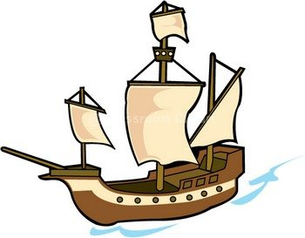 | 2.  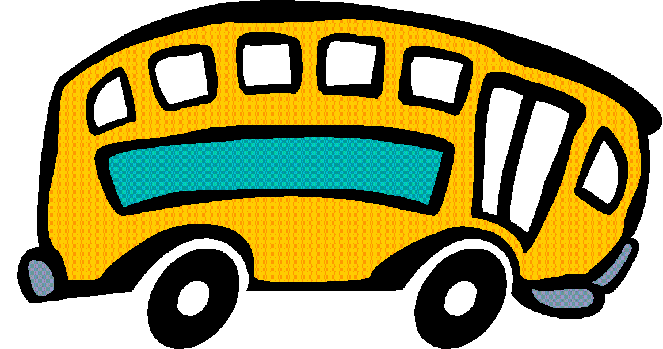 | 3.  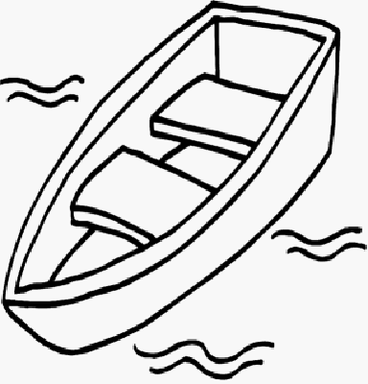 | 4.  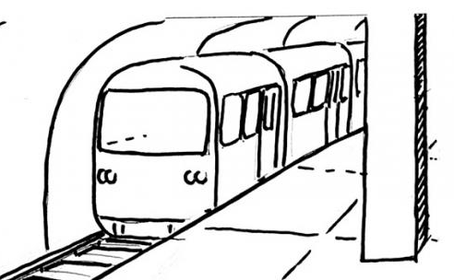 | 5.  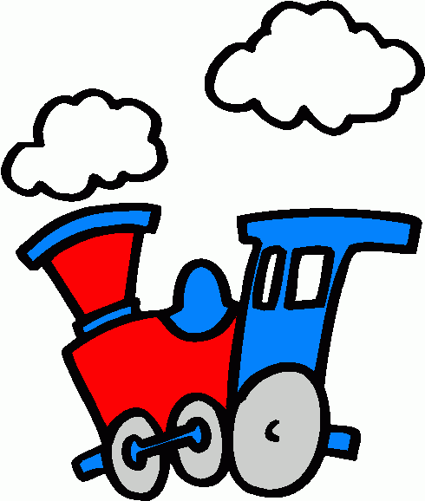
6.  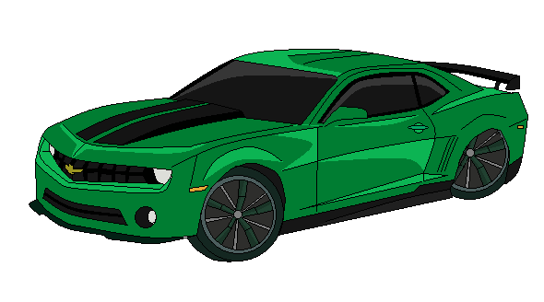 | 7.  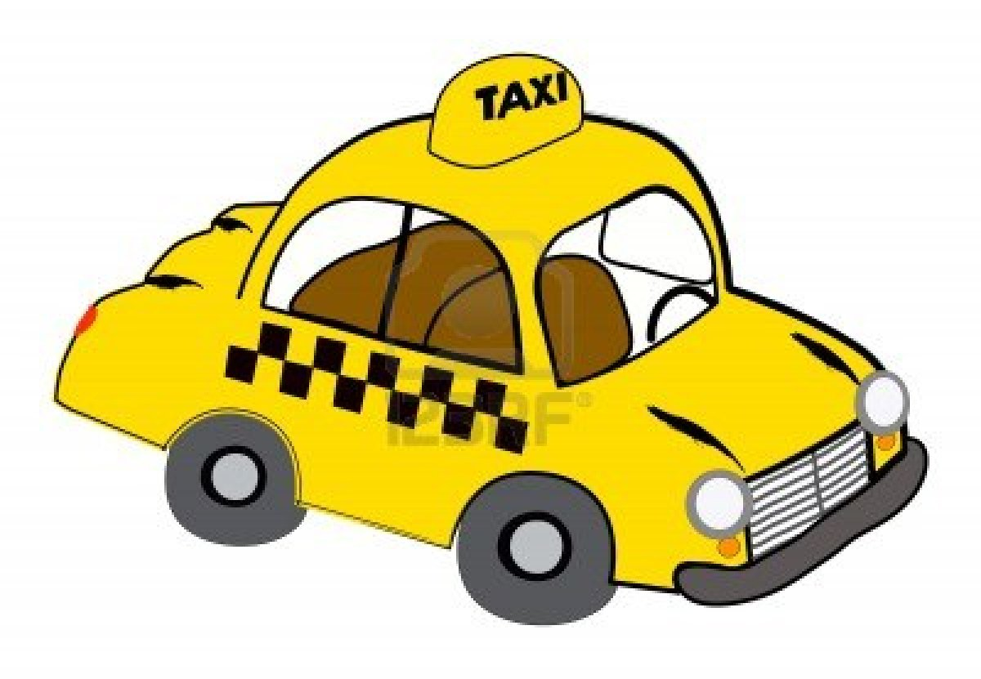 | 8.  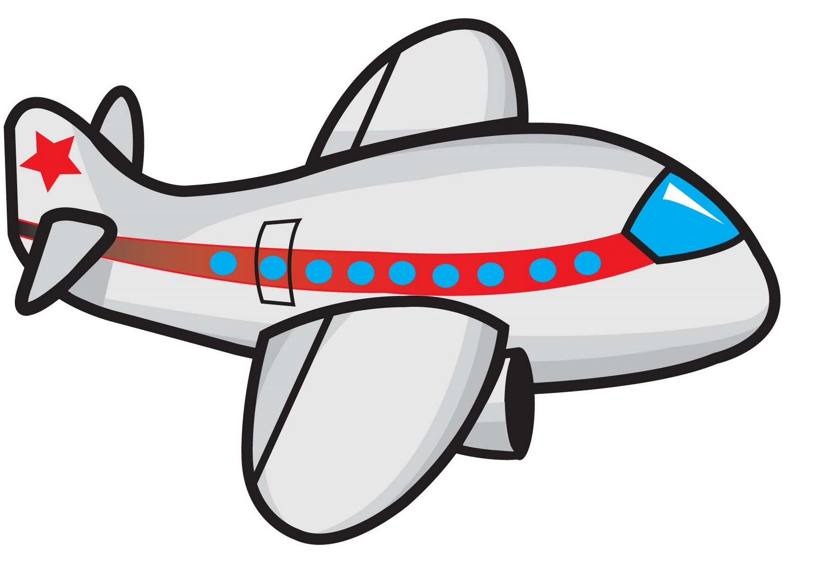 | 9.  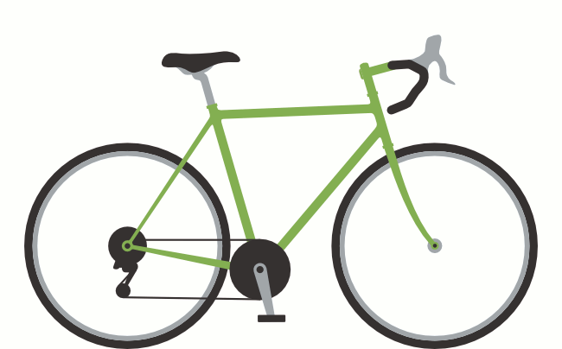 | 10.

 | boat |  | taxi
 | bike |  | plane
 | train |  | metro
 | car |  | ship
 | bus

